Rafael Canseco

9/20/24

CS-340

3-1 Milestone: Database Indexing and Authentication

Part I: Importing and Indexing a Data Set  
1. Open the terminal in Apporto to access the Linux shell. Import the Austin Animal Center (AAC) Outcomes CSV data into MongoDB using the mongoimport tool. Set the database name to "AAC" and the collection name to "animals." Capture screenshots of both the import command and its execution.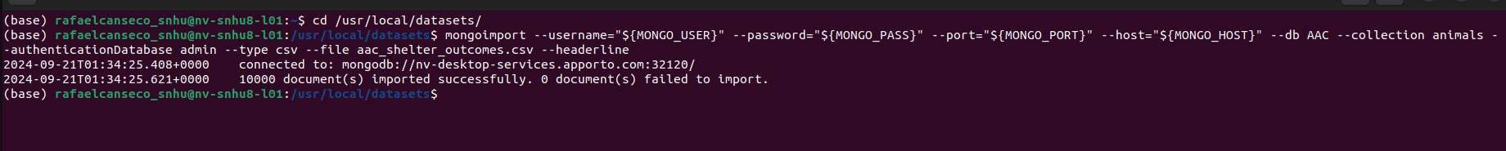

2. After importing your data set, open the mongo shell. Create a simple index on the key “breed.” Show an example query using this index and use the explain function to verify that the index will be used. Take screenshots of your example query.

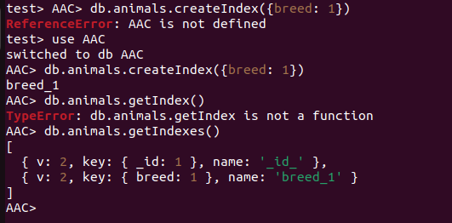

3. Create a compound index that will improve the performance of queries looking for breeds that have an “outcome type” of “Transfer.”

Part II: User Authentication

1. Create a new user account called “accuser” for the database AAC in the mongo shell. Refer to steps 6–7 of the MongoDB Manual Enable Access Control tutorial for help with this task. You will need to modify the commands, so the account name is “accuser.” Additional information with respect to user management may be found in the User Management in MongoDB document.

1. Take a screenshot of your login process to MongoDB using the mongo shell. Be sure you can access MongoDB and list the databases using both the admin and accuser accounts. This task will verify that your accounts are working. You should be able to include the login commands for both accounts in one screenshot, but if you cannot, include two screenshots to show both login commands.

